Mechanics of Writing
Dr. Fatemah Mahsain
Course number 133
Sun/Tue/Thu 3:00-4:00
Classroom: B7, F15
-Contact:
Email: fh.mahsain@paaet.edu.kw
Twitter: dr_fmahsain
Website: www.fatemahmahsain.com
Snapchat: dr.fmahsain
- Office hours:
Sunday & Tuesday from 1:00-2:00 or by appointment, Building 9, Room 35
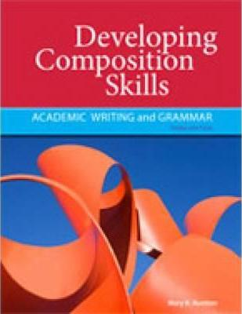
- Textbooks:
Developing Composition Skills, By Mary Ruetten, Third Edition
-Any English dictionary

- Grade distribution:
40% Final
30% Midterm
30% Assignments
Extra marks for complete attendance and participation

