Applied Linguistics
Dr. Fatemah Mahsain
Course number 351
Sun/Tue/Thu 10:00-10:50
Classroom: B7, F16
-Contact:
Email: fh.mahsain@paaet.edu.kw
Website: www.fatemahmahsain.com
Instagram: dr.f.mahsain
Twitter: dr_fmahsain
- Office hours:
Sunday & Tuesday from 11:00-11:50 or by appointment, Building 9, Room 35

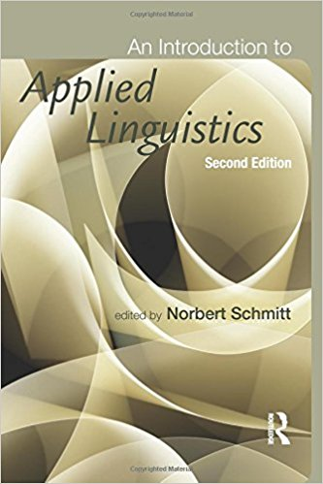
- Textbook:
An Introduction to Applied Linguistics. Second Edition By Norbet Schmitt

- Grade distribution:
45% Final
40% Midterm
10% Quiz
5% Assignment/project/presentation
Extra marks for complete attendance and participation

